**Assignment 2**

*// QUESTION 1-->Hotel Menu System Design, We can order the Items and we get a Bill*

import java.util.Scanner;

public class HotelMenu {

    public static void main(String[] args) {

        System.out.println("WELCOME TO THE HOTEL");

        System.out.println("PRESS THE FOLLOWING KEY TO ORDER YOUR FAVOURITE FODD");

        Scanner I=new Scanner(System.in);

        int totalbill=0;

        while(true){

            System.out.println("PRESS 1 for PIZZA(Amount-Rs900)");

            System.out.println("PRESS 2 for NOODLES(Amount-Rs499)");

            System.out.println("PRESS 3 for BURGER(Amount-Rs120)");

            System.out.println("PRESS 4 for CHICKEN WINGS(Amount-Rs720)");

            System.out.println("PRESS 5 for ICECREAM(Amount-Rs200)");

System.out.println("PRESS 6 to display BILL");

System.out.print("ENTER YOUR CHOICE-:");

int ch=I.nextInt();

switch(ch){

            case 1: System.out.println("\nThanks for ordering Pizza ");

             System.out.println();

             System.out.println();

             totalbill+=900;

             break;

             case 2: System.out.println("\nThanks for ordering Noodles");

             System.out.println();

             System.out.println();

             totalbill+=499;

             break;

             case 3: System.out.println("\nThanks for ordering Burger ");

             System.out.println();

             System.out.println();

             totalbill+=120;

             break;

             case 4: System.out.println("\nThanks for ordering Chicken Wings ");

             System.out.println();

             System.out.println();

             totalbill+=720;

             break;

             case 5: System.out.println("\nThanks for ordering Icecream ");

             System.out.println();

             System.out.println();

             totalbill+=200;

             break;

             case 6: System.out.print("\nYOUR TOTAL BILL GENERATED IS--:"+totalbill);

             System.out.println();

             System.out.println();

             System.exit(1);

             break;

             default:System.out.println("SORRY,BUT YOU ARE ENTERING A WRONG CHOICE..");

}

        }

    }

}

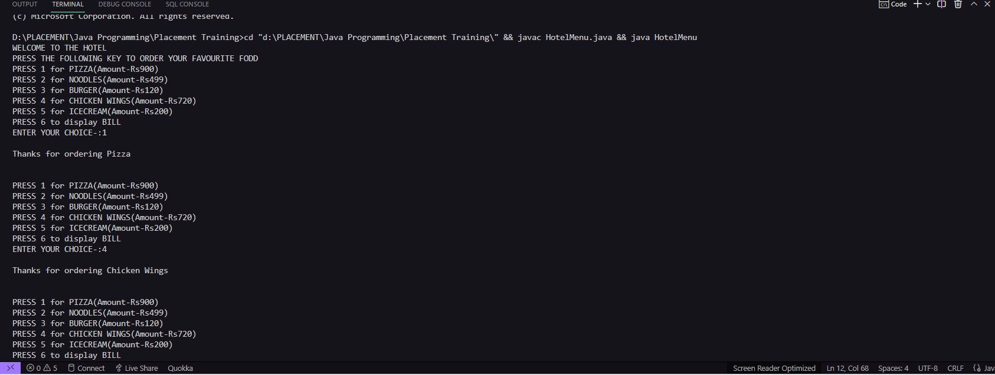

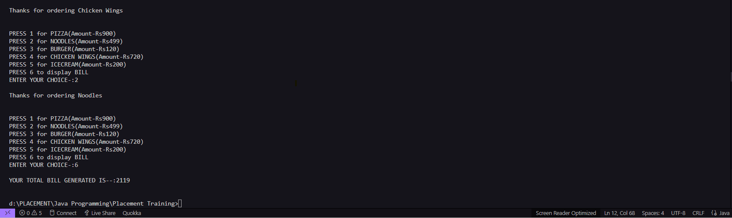

*// QUESTION 2 Basic ATM machine Menu*

import java.util.Scanner;

public class Atm

{

    public static void main(String args[] )

    {

        int accountbalance = 5000, withdrawal, deposit;

        Scanner I = new Scanner(System.in);

        while(true)

        {

            System.out.println("Welcome to The Bankers.....");

            System.out.println("Press 1 for Withdraw");

            System.out.println("Press 2 for Deposit");

            System.out.println("Press 3 for Check Balance");

            System.out.println("Press 4 for EXIT");

            System.out.print("Please enter your choice:");

            int ch = I.nextInt();

            switch(ch)

            {

                case 1:

                System.out.print("Please enter money which you want to withdrawn:");

                withdrawal = I.nextInt();

                if(accountbalance >= withdrawal)

                {

                    System.out.println("Collect your money");

                   accountbalance =accountbalance - withdrawal;

                }

                else

                {

                    System.out.println("Balance is insuffcient");

                }

                System.out.println("");

                break;

                case 2:

                System.out.print("Please enter money to be deposited:");

                deposit = I.nextInt();

                accountbalance = accountbalance + deposit;

                System.out.println("Your Money has been deposited successfully");

                System.out.println("");

                break;

                case 3:

                System.out.println("Balance : "+accountbalance);

                System.out.println("");

                break;

                case 4:

                System.out.println("Thank-You for Using The Services");

                System.exit(1);

            }

        }

    }

}

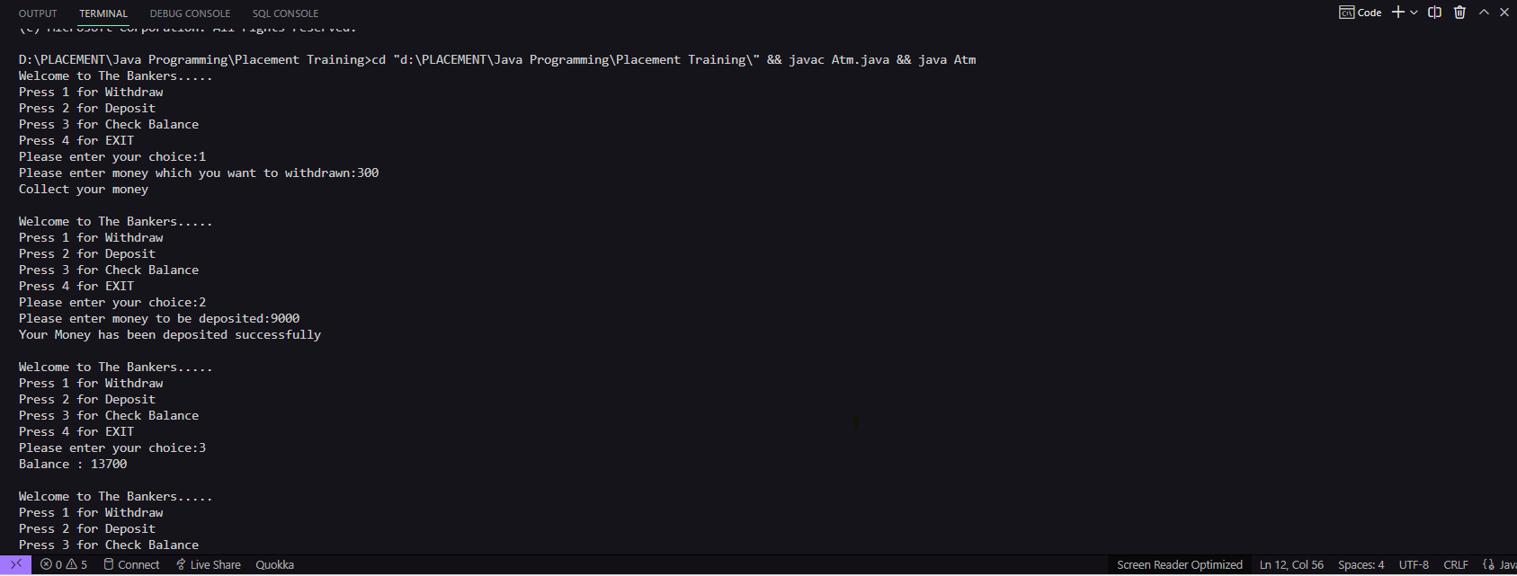

*// QUESTION 3 Grading System (Student 3 Subject Marks ) Total Marks, Percentage , Grade e.g >=90 A Grade , <90 to 70 B Grade , <70 to 60 C Grade , 60< to 50 D Grade, Otherwise F Grade*

import java.util.Scanner;

public class GradingSystem {

    public static void main(String[] args) {

        Scanner I=new Scanner(System.in);

        System.out.print("Enter 1st subject marks--:");

        int m1=I.nextInt();

        System.out.print("\nEnter 2st subject marks--:");

        int m2=I.nextInt();

        System.out.print("\nEnter 3st subject marks--:");

        int m3=I.nextInt();

        double percentage=(m1+m2+m3)*100/300;

        if((int)percentage>=90)

        System.out.println("Your grade is A");

        else if((int)percentage>=70 && (int)percentage<90)

        System.out.println("Your grade is B");

        else if((int)percentage>=60 && (int)percentage<70)

        System.out.println("Your grade is C");

        else if((int)percentage>=50 && (int)percentage<60)

        System.out.println("Your grade is D");

        else

        System.out.println("Your grade is F");

        I.close();

    }

}

*// QUESTION 4-Build a Calc (Math Operations) Cube, Abs , Power, (Java Math Class) , Decimal to Binary , Binary to Decimal , Octal , Hexa (Wrapper Classses)*

import java.util.Scanner;

public class Calculator {

    public static void main(String[] args) {

        Scanner I = new Scanner(System.in);

        System.out.println("Press 1 for Cube");

            System.out.println("Press 2 for Abs");

            System.out.println("Press 3 for Power ");

            System.out.println("Press 4 for Decimal to Binary");

            System.out.println("Press 5 for Binary to Decimal");

            System.out.println("Press 6 for Binary to Octal");

            System.out.println("Press 7 for Binary to Hexadecimal");

            System.out.print("Enter your choice");

            int ch=I.nextInt();

            switch(ch){

                case 1:System.out.println("Enter a number-:");

                int n1=I.nextInt();

                System.out.println("The cube of a number is"+Math.pow(n1,3));

                break;

                case 2:System.out.println("Enter a number-:");

                int n2=I.nextInt();

                System.out.println("The absolute of a number is"+Math.abs(n2));

                break;

                case 3:System.out.println("Enter a number-:");

                int n3=I.nextInt();

                System.out.println("Enter the power of number");

                int p=I.nextInt();

                System.out.println("The power of a number is"+Math.pow(n3,p));

                break;

                case 4:System.out.println("Enter a number in decimal-:");

                int n4=I.nextInt();

                System.out.println("Decimal to Binary is"+Integer.toBinaryString(n4));

                break;

                case 5:System.out.println("Enter a number in binary-:");

                String n5=I.next();

                System.out.println("Binary to Decimal is"+Integer.parseInt(n5,2));

                break;

                case 6:System.out.println("Enter a number in binary-:");

                String n6=I.next();

                System.out.println("Binary to octal is"+Integer.toHexString(Integer.parseInt(n6,2)));

                break;

                default:System.out.println("Wrong Choice");

            }

        }

}

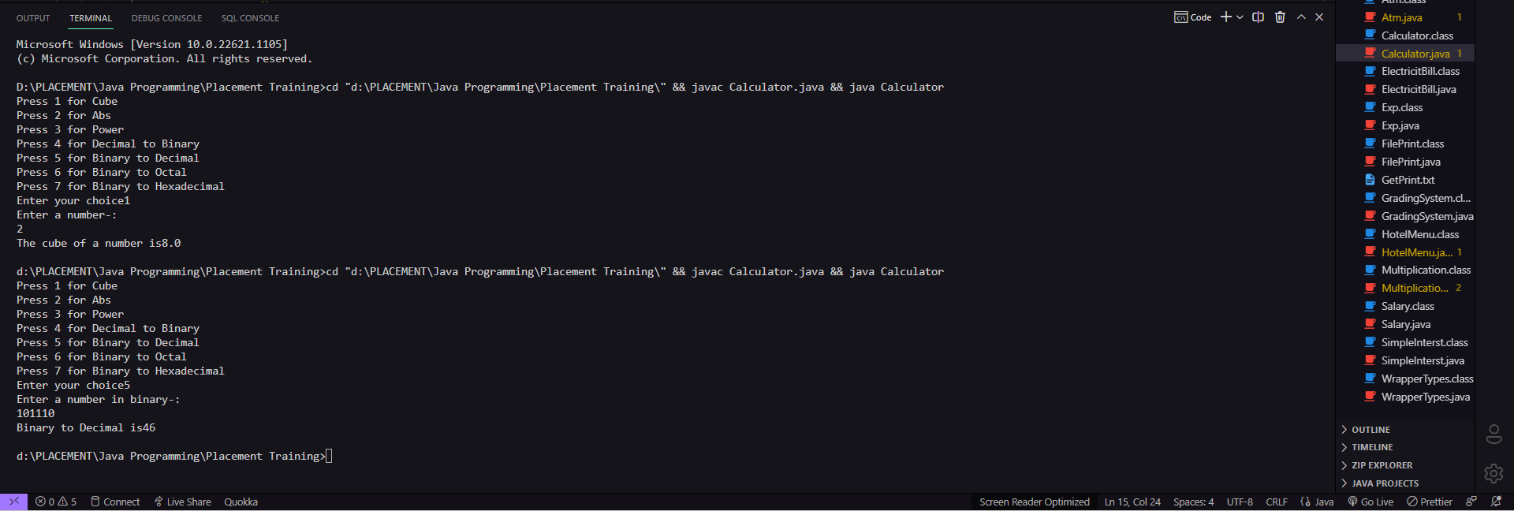

*// QUESTION 5-Electricity Bill, Based on Given Unit  e.g Upto 199 Units Per unit Charge @1.20 , 200 to 400 @1.50 Unit 400 to 600 Bill @1.80 , > 600 @2.00 , if bill Exceed Rs 400 Surcharge 15%*

import java.util.Scanner;

*public* class ElectricitBill {

*public* *static* void main(String[] *args*) {

        Scanner I=*new* Scanner(System.in);

        System.out.print("Enter the consumed unit-:");

        int unit=I.nextInt();

        double amt=0,surcharge=0;

*// boolean un;*

*if*(unit<200)

        amt=unit*1.20;

*else* *if*(unit>=200 && unit<400)

        amt=199*1.20+(unit-199)*1.50;

*else* *if*(unit>=400 && unit < 600)

        amt=199*1.20+200*1.50 +(unit-399)*1.80;

*else*

        amt=199*1.20+200*1.50 +200*1.80+(unit-599)*2.0;

*if*(amt>400)

        surcharge=amt*0.15;

        System.out.println("The Net amount is-: Rs "+(float)(amt+surcharge));

        I.close();

    }

}

